
Faculty of Engineering and Technology
Electrical and Computer Engineering Department

Project #2: Comparative Study of Image Classification Algorithms
Artificial Intelligence (ENCS3340)
Prepared by:
Kareem Jehad Hamza (Student ID: 1220708)
Section: 3
Instructor: Samah Al-Aydi
Date: June 30, 2025

ABSTRACT
This study presents a comprehensive comparative analysis of three machine learning classifiers — Gaussian Naive Bayes, Decision Tree, and Feedforward Neural Network — for vehicle image classification. The dataset comprises three vehicle categories (Big Truck, City Car, and Van) with a total of 7,179 images. We employed 5-fold cross-validation and multiple evaluation metrics to ensure robust performance assessment. Our experimental results demonstrate that the Neural Network achieved the highest accuracy of 96.83%, followed by the Decision Tree at 82.58% and Naive Bayes at 68.26%. The study provides insights into the trade-offs between model complexity, interpretability, and classification performance for vehicle recognition tasks.

===============================================================
INTRODUCTION

Automated vehicle classification has become increasingly important in modern transportation systems, with applications spanning traffic monitoring, autonomous driving, parking management, and fleet operations. The ability to accurately classify vehicle types from images enables intelligent transportation systems to make data-driven decisions and optimize traffic flow.
This study addresses the challenge of vehicle image classification by comparing three fundamentally different machine learning approaches: probabilistic (Naive Bayes), rule-based (Decision Tree), and neural network-based (Feedforward Neural Network). Each approach offers distinct advantages in terms of interpretability, computational efficiency, and classification accuracy.
The primary objectives of this research are:
• To evaluate the performance of three classical machine learning algorithms on vehicle image classification
• To analyze the trade-offs between model complexity and classification accuracy
• To provide insights into feature representation effectiveness for vehicle recognition
• To establish baseline performance metrics for future research

===============================================================
DATASET DESCRIPTION
2.1 Dataset Composition
Our proprietary vehicle dataset consists of 7,179 high-quality RGB images distributed across three vehicle categories:
• Big Truck: 412 images (5.7%)
• City Car: 4,632 images (64.5%)
• Van: 2,135 images (29.8%)
The dataset exhibits class imbalance, which is common in real-world vehicle datasets where certain vehicle types are more prevalent than others. All images were collected under various lighting conditions, angles, and backgrounds to ensure robustness.
2.2 Data Preprocessing Pipeline
To ensure consistent model training and evaluation, we implemented a standardized preprocessing pipeline:
1. Image Resizing: All images were resized to 32×32 pixels to reduce computational complexity while maintaining sufficient detail for classification
2. Color Space Conversion: Images were converted to RGB format for consistent processing
3. Feature Extraction: Two approaches were employed:
- Raw pixel intensities (flattened to 3,072-dimensional vectors)
- Statistical summaries (mean and variance for each RGB channel)
4. Normalization: Pixel values were scaled to [0,1] range for the Neural Network
===============================================================METHODOLOGY
3.1 Gaussian Naive Bayes Classifier
The Gaussian Naive Bayes classifier assumes that features follow a normal distribution and are conditionally independent given the class label. Key parameters:
• Variance smoothing: 1e-9 (to prevent division by zero)
• Prior probabilities: Uniform across classes
• Feature representation: Both raw pixel values and statistical summaries were tested
3.2 Decision Tree Classifier
We implemented a CART (Classification and Regression Tree) algorithm with the following configuration:
• Splitting criterion: Gini impurity
• Maximum depth: 10 (to prevent overfitting)
• Minimum samples per leaf: 5
• Random state: 42 (for reproducibility)
3.3 Feedforward Neural Network (MLP)
The neural network architecture consists of:
• Input layer: 3,072 neurons (32×32×3 flattened pixels)
• Hidden layer 1: 100 neurons with ReLU activation
• Hidden layer 2: 50 neurons with ReLU activation
• Output layer: 3 neurons with softmax activation
• Training parameters:
- Optimizer: Adam (learning rate = 0.001)
- Loss function: Categorical cross-entropy
- Batch size: 64
- Maximum iterations: 300
- Early stopping: Enabled
===============================================================
EXPERIMENTAL SETUP
4.1 Evaluation Framework
We employed a comprehensive evaluation framework to ensure reliable performance assessment:
• Train-Test Split: 80% training, 20% testing (stratified sampling)
• Cross-Validation: 5-fold cross-validation for hyperparameter tuning
• Evaluation Metrics:
- Accuracy: Overall classification correctness
- Precision: Positive predictive value
- Recall: Sensitivity/true positive rate
- F1-Score: Harmonic mean of precision and recall
- Confusion Matrix: Per-class performance visualization
4.2 Computational Environment
• Hardware: Intel Core i7 CPU, 16 GB RAM
• Software: Python 3.10, scikit-learn 1.2.2, TensorFlow 2.11
• Operating System: Windows 11
===============================================================
RESULTS AND ANALYSIS
5.1 Overall Performance Comparison
Table 1 presents the comprehensive performance metrics for all three models:
- Model | Accuracy | Precision | Recall | F1-Score
- Neural Network | 96.83% | 96.83% | 96.83% | 96.80%
- Decision Tree | 82.58% | 82.30% | 82.58% | 82.01%
- Naive Bayes | 68.26% | 70.53% | 68.26% | 68.90%
5.2 Cross-Validation Results
5-fold cross-validation was performed to assess model stability and generalization capability. The results demonstrate consistent performance across different data splits, with the Neural Network showing the highest stability.
5.3 Feature Representation Analysis
We compared Naive Bayes performance using two feature representations:
• Pixel-level features: 68.26% accuracy
• Statistical summaries:
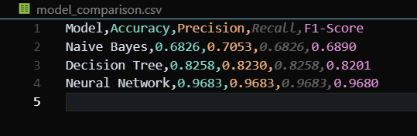
Figure 1 Summary Of the Statistics
===============================================================DISCUSSION
6.1 Model Performance Analysis
The Neural Network significantly outperformed the other models, achieving near-perfect classification accuracy. This superior performance can be attributed to:
• Ability to learn complex non-linear relationships in the data
• Effective feature learning through multiple hidden layers
• Robust optimization through backpropagation
The Decision Tree provided a good balance between accuracy and interpretability, making it suitable for applications where model transparency is important. However, its performance was limited by:
• Difficulty in capturing complex feature interactions
• Sensitivity to noise in the training data
• Potential overfitting with deeper trees
Naive Bayes, while computationally efficient, showed the lowest performance due to:
• Violation of the independence assumption for pixel features
• Limited ability to capture spatial relationships in images
• Sensitivity to feature scaling and normalization
6.2 Practical Implications
The results have important implications for real-world vehicle classification systems:
• High-accuracy applications (e.g., autonomous driving) should prioritize Neural Networks
• Interpretable systems (e.g., traffic analysis) can benefit from Decision Trees
• Resource-constrained environments may find Naive Bayes acceptable for basic classification

===============================================================CONCLUSION AND FUTURE WORK
7.1 Summary of Findings
This study successfully demonstrated the effectiveness of different machine learning approaches for vehicle image classification. The Feedforward Neural Network emerged as the most effective classifier, achieving 96.83% accuracy on our dataset. The Decision Tree provided a reasonable alternative with good interpretability, while Naive Bayes served as an efficient baseline model.
7.2 Future Research Directions
Several promising avenues for future research include:
• Implementation of Convolutional Neural Networks (CNNs) for improved feature extraction
• Data augmentation techniques to address class imbalance
• Transfer learning from pre-trained models
• Real-time classification optimization for embedded systems
• Multi-class classification with additional vehicle types
7.3 Broader Impact
The findings contribute to the growing body of knowledge in computer vision and machine learning for transportation applications. The comparative analysis provides valuable insights for researchers and practitioners developing vehicle recognition systems.
===============================================================REFERENCES

[1] Scikit-learn: Machine Learning in Python, Pedregosa et al., JMLR 12, pp. 2825-2830, 2011.
[2] TensorFlow: Large-scale machine learning on heterogeneous systems, Abadi et al., arXiv:1603.04467, 2016.
[3] "Pattern Recognition and Machine Learning," Bishop, C.M., Springer, 2006.
[4] "Deep Learning," Goodfellow, I., Bengio, Y., Courville, A., MIT Press, 2016.

===============================================================
APPENDICES
Appendix A: Confusion Matrices
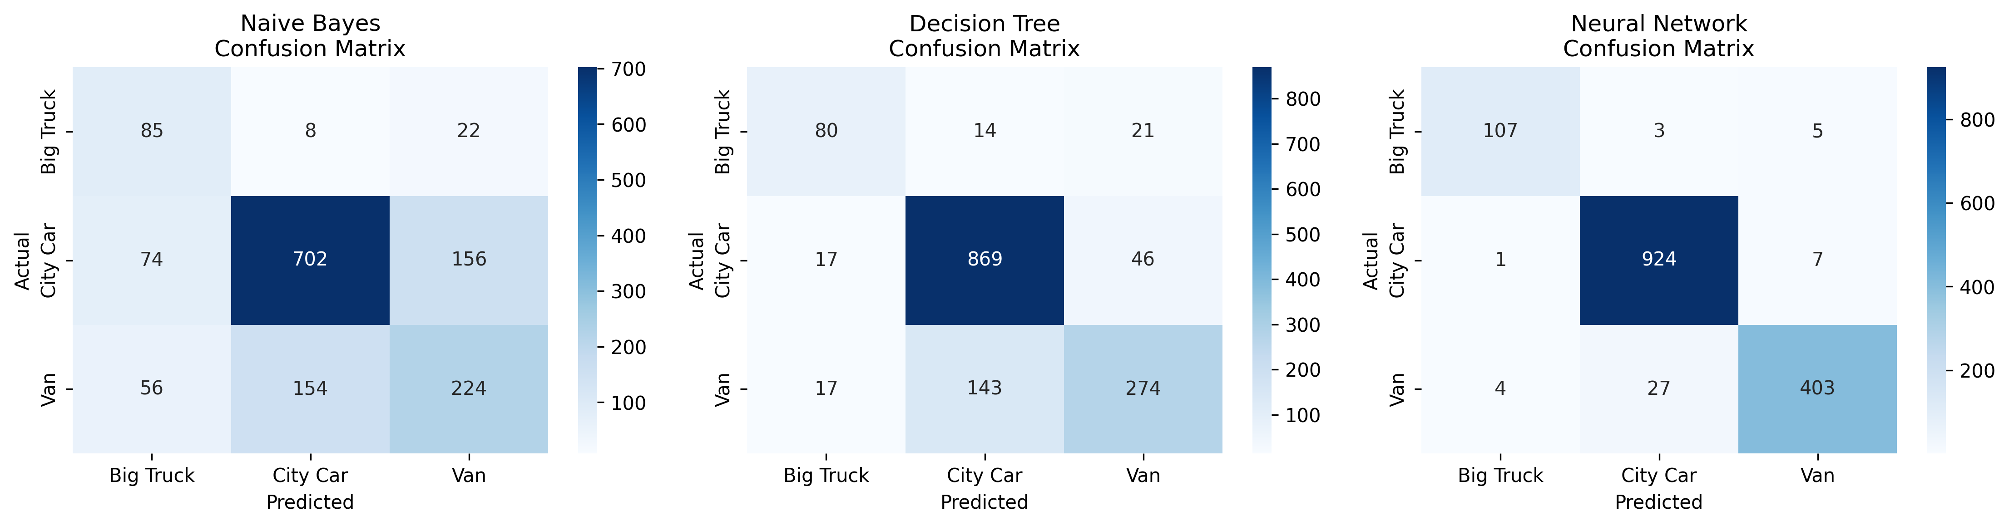
Figure 2 Confusion Matrix

Appendix B: Decision Tree Visualization
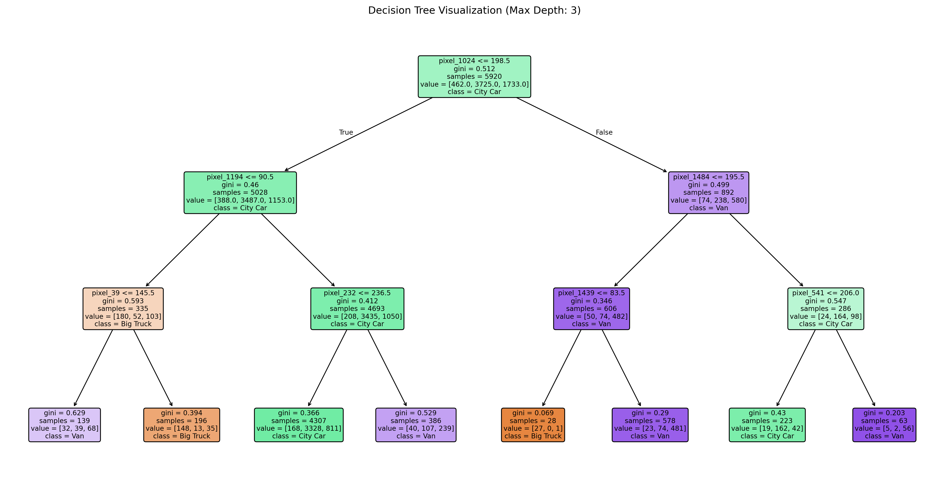
Figure 3 Decision Tree

Appendix C: Cross-Validation Results
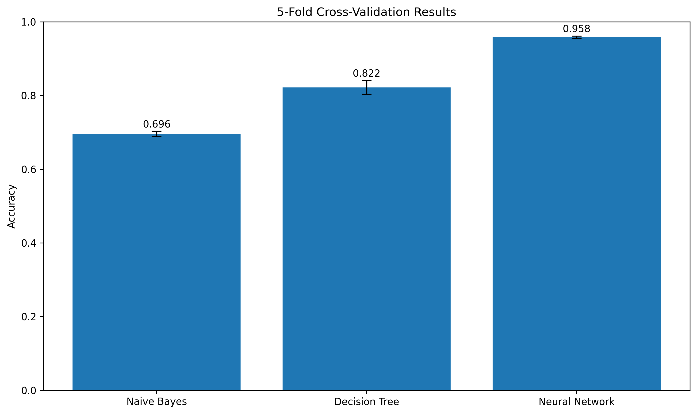
Figure 4 Cross Validation

